- The Budget delivered a significant loosening of fiscal policy compared to March, although policy will still continue to tighten over the course of this parliament. Changes to the fiscal rules and tax hikes provided space for large increases in day-to-day spending and public investment.
- Markets reacted poorly, but we don’t expect this to be a repeat of the crisis that followed the 2022 mini-Budget. The rise in gilt yields was partly because the loosening of fiscal policy implies more gradual interest rate cuts from the Bank of England. Though the extra borrowing was more than expected, the Chancellor replaced implausible and unspecified spending cuts with specific tax hikes, offering a more credible plan to tighten policy.
Going into this week's Budget, Chancellor Rachel Reeves had to walk a tightrope between boosting current and capital spending, while maintaining fiscal credibility and managing poor debt dynamics. Markets didn't think she got the balance right – the 10-year gilt yield is up 23bps since her speech began.
The government's approach was framed by two new fiscal rules. The new borrowing rule targets a balanced current budget (i.e. day-to-day spending matched with government revenue). The Chancellor also changed the debt rule to target a falling ratio of public sector net financial liabilities to GDP, to try to recognise some of the benefits of investment. Initially, the rules will be evaluated for the same five-year horizon as before. But when 2029-2030 becomes the third year of the forecast, the rules will be assessed on a rolling three-year basis. We think the shorter timeframe will help to reinforce credibility in the fiscal plans.
The Office for Budget Responsibility's new forecast showed that the change in the debt measure increased the headroom against the debt rule by £22bn. The Chancellor increased government investment by £23bn in 2029-2030, compared to previous plans (Chart 1). But those plans involved investment dropping to a 13-year low as a share of GDP. The new plans show a more modest fall and keep the level of investment above the average of the past 20 years. Still, capital spending will remain low by international standards and the extent to which higher public investment boosts growth will depend on how it is allocated.
Chart 1: The Budget delivered a net loosening policy relative to the March Budget
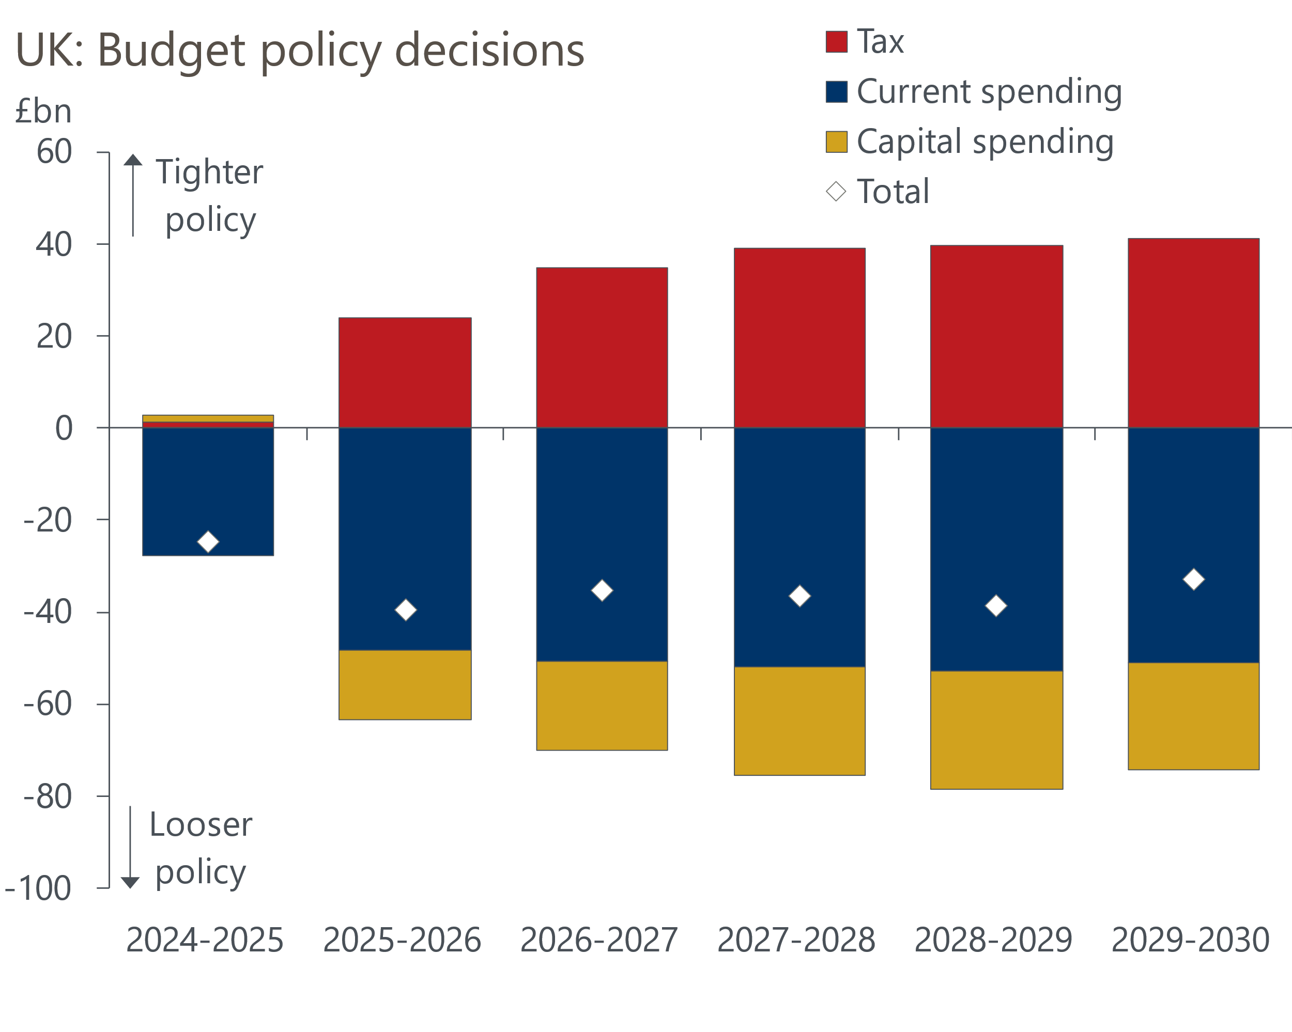
Source: HM Treasury

The OBR's pre-measures forecast offered only slightly more headroom against the new borrowing rule than before, so any increase in current spending had to be largely financed by higher taxation. Reeves opted to introduce a series of tax measures to raise £41bn by 2029-2030. Of these, almost two-thirds came from increasing the main rate of employers' national insurance contributions by 1.2ppts to 15% and lowering the threshold at which companies must start paying NICs. Other measures included an increase to the main rates of capital gains tax, reforms to inheritance tax, and abolishing the 'non-dom' tax regime.
The Chancellor increased day-to-day expenditure by £51bn by 2029-2030, which leaves a margin of error of just under £10bn against the new borrowing rule. A decent chunk of the extra spending relates to the overspend for the current fiscal year that was identified in the Chancellor's July review, with much of this spending set to recur in future years. Up to 2029-2030, departmental spending will increase by an average of 1.5% per year in real terms, up from the previously planned 0.9%. But given the strength of pressures from the NHS, schools, and defence, the Office for Budget Responsibility projected that spending on unprotected departments will still fall from 2025-2026 in real terms.
Shortly after the Chancellor finished her Budget speech in the House of Commons and the OBR published their Economic and Fiscal Outlook, government bond yields started to rise sharply. The 10-year gilt yield reached a peak of 4.55% on Thursday afternoon, up from 4.19% during Reeves' speech, but subsequently retreated to 4.43% at market close on Thursday.
Some commentators have argued the markets are concerned about fiscal sustainability and predicted a repeat of the crisis that followed the mini-Budget in September 2022. But we think the picture is more nuanced and that the situation is very different compared with two years ago. The movements that followed the Budget came on the back of a very volatile period for global bond yields, and at Thursday's close, the spread over US Treasuries was still below recent peaks (Chart 2).
Chart 2: The spread of UK gilts over bunds and Treasuries has widened slightly this week
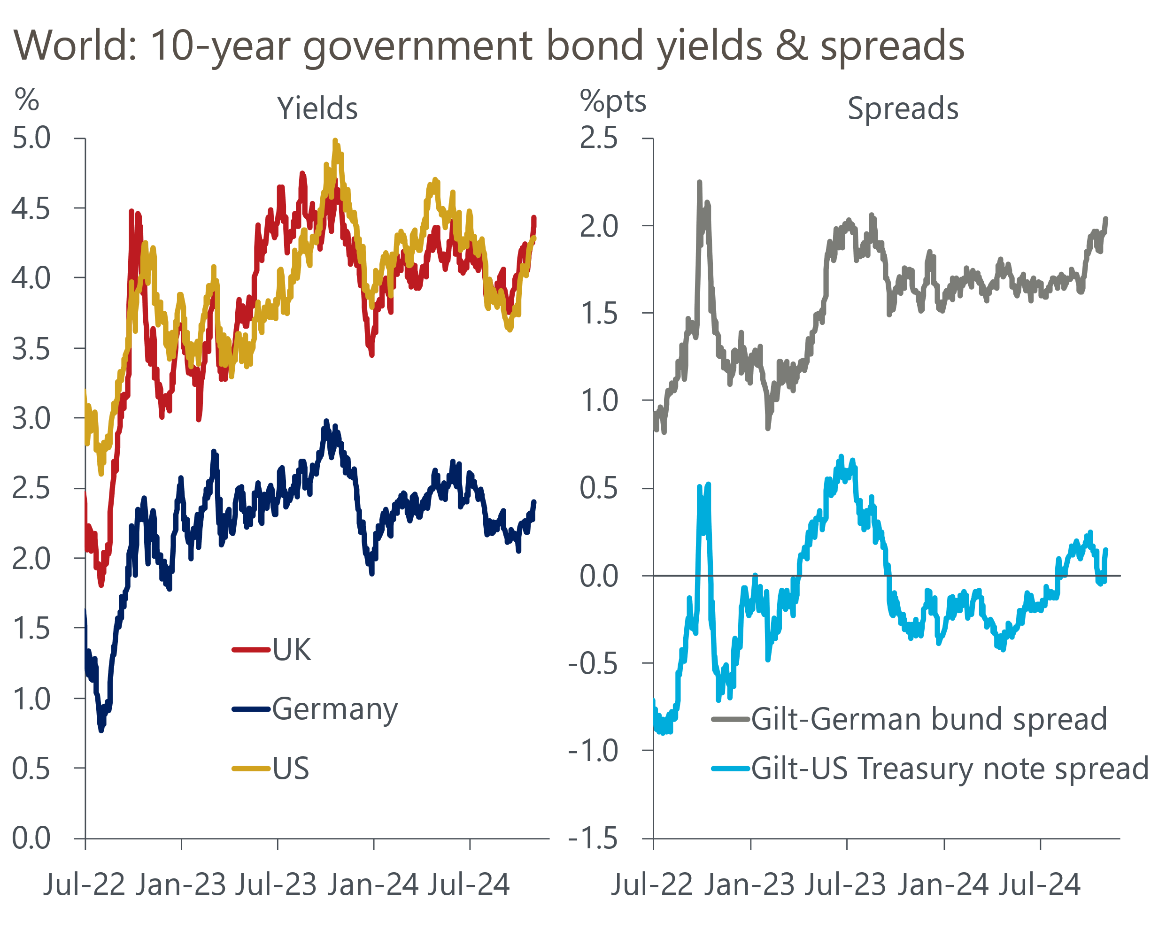
Source: Haver Analytics
Of the domestic element of the increase in yields, some relates to the idea that with the Budget delivering a net loosening of fiscal policy compared with the March Budget, there may be less space for the Bank of England's Monetary Policy Committee to cut interest rates quickly. Indeed, market expectations for Bank Rate at the end of 2025 were more than 30bps higher on Thursday than before the Budget speech.
The remainder of the increase in yields appears to reflect three issues. First, that the size of Wednesday's package was larger than markets had expected. Second, that around a third of the extra borrowing is to finance day-to-day spending, jarring with the message about borrowing to invest. And third, that the Chancellor has left little headroom against the borrowing rule, with plenty of potential for slippage. These are all very valid concerns. But set against that, the government is still tightening fiscal policy over the course of this parliament and has replaced implausibly tight spending assumptions with tax hikes, which we think represents a much more credible route towards consolidation.

The week ahead
Next week's main event is the Monetary Policy Committee meeting for November. The clear message from the August and September meetings was that the MPC would adopt a gradual approach to removing policy restraint. Given a 25bps cut in August was followed by a hold in September, and recent economic data has come in slightly softer than had been expected, we regard another 25bps cut at November's meeting as virtually certain. But we will be watching closely to see if there's any indication that the majority of MPC members are willing to depart from the 'cut-hold' pattern and back a faster pace of rate cuts through the winter.
Next week also sees the S&P Global services survey for October released. The flash survey reported weaker activity growth and we see little reason to suggest that the final reading will offer a different result. We expect the construction survey to complete a full house of softer S&P Global survey outturns in October.
Table 1: Week ahead calendar
Date | Events | Period | Measure | Unit | Previous | Forecast
Nov 5 | S&P Global services | Oct | PMI | % bal | 51.8 | 51.8
Nov 5 | S&P Global composite | Oct | PMI | % bal | 51.7 | 51.7
Nov 6 | S&P Global construction | Oct | PMI | % bal | 57.2 | 55.5
Nov 7 | Halifax house prices | Oct | m/m | % | 0.3 | 0.3
Nov 7 | Halifax house prices | Oct | y/y | % | 4.7 | 4.3
Nov 7 | BoE Bank Rate decision | Nov | Bank Rate | % | 5.00 | 4.75
Source: Oxford Economics

Key forecasts
Table 2: UK forecast overview
(Annual percentage changes unless specified)
 | 2022 | 2023 | 2024 | 2025 | 2026 | 2027
GDP | 4.8 | 0.3 | 1.0 | 1.5 | 1.6 | 1.7
Private consumption | 7.3 | 0.5 | 0.8 | 1.9 | 1.8 | 1.6
Fixed investment | 5.1 | -0.1 | 0.6 | 1.3 | 2.5 | 2.1
Government consumption | 0.6 | 0.6 | 2.3 | 1.9 | 1.5 | 1.5
Exports of goods and services | 12.6 | -2.2 | -0.8 | 3.0 | 1.9 | 1.6
Imports of goods and services | 13.0 | -3.4 | 2.8 | 3.1 | 2.5 | 1.7
Industrial Production | -6.4 | -1.2 | -0.8 | 1.0 | 1.2 | 0.9
Consumer prices | 9.1 | 7.3 | 2.5 | 2.5 | 2.3 | 2.1
Unemployment rate (%) | 3.9 | 4.0 | 4.3 | 4.3 | 4.1 | 3.9
Current a/c balance (% of GDP) | -2.2 | -2.0 | -2.9 | -2.8 | -2.9 | -2.8
Government balance (% of GDP) | 4.1 | 4.9 | 3.7 | 2.8 | 2.1 | 1.4
Cen. bank policy rate (%, EOP) | 3.50 | 5.25 | 4.75 | 3.75 | 2.75 | 2.00
10yr govt. bond yield (%, EOP) | 3.67 | 3.54 | 4.00 | 3.75 | 3.24 | 2.85
Exchange rate (US$ per £, EOP) | 1.20 | 1.27 | 1.31 | 1.32 | 1.32 | 1.33
Exchange rate (euro per £, EOP) | 1.13 | 1.15 | 1.19 | 1.18 | 1.18 | 1.17
Source: Oxford Economics
Table 3: Quarterly forecasts for the UK
 | 2024 |  |  |  | 2025
 | Q1 | Q2 | Q3 | Q4 | Q1 | Q2 | Q3 | Q4
GDP (% year) | 0.3 | 0.7 | 1.1 | 1.9 | 1.6 | 1.5 | 1.6 | 1.5
CPI inflation (% year) | 3.5 | 2.1 | 2.1 | 2.4 | 2.5 | 2.3 | 2.6 | 2.5
Bank Rate (%, EOP) | 5.25 | 5.25 | 5.00 | 4.75 | 4.50 | 4.25 | 4.00 | 3.75
10yr gilt yield (%, EOP) | 3.95 | 4.17 | 4.00 | 4.00 | 3.98 | 3.92 | 3.84 | 3.75
US$ per £ (EOP) | 1.26 | 1.26 | 1.34 | 1.31 | 1.31 | 1.32 | 1.32 | 1.32
Euro per £ (EOP) | 1.17 | 1.18 | 1.20 | 1.19 | 1.19 | 1.19 | 1.19 | 1.18
Source: Oxford Economics

Latest Country Economic Forecast:
October 15, 2024

Recent publications

Data Insights
Manufacturing PMI slipped below 50 in October
Cheaper deals supported a further rise in mortgage approvals
October PMI gives further signal growth has softened in H2
September public finances point to another borrowing overshoot
September's data confirm a strong Q3 for retail sales

Research Briefings
New fiscal rules create room for looser policy
Can PSNW be used for a fiscal rule?
Why business investment is poised to pick up
Looser labour market could pave the way for faster rate cuts
How changing the debt rule could shape the Budget

Contacts

Oxford Economics' UK team
- Andrew Goodwin - Chief UK Economist - agoodwin@oxfordeconomics.com
- Edward Allenby - UK Economist - eallenby@oxfordeconomics.com

